Exp1. implement insertion sort

#include <math.h>

#include <stdio.h>

void insertionSort(int arr[], int n)

{

int i, key, j;

for (i = 1; i < n; i++) {

key = arr[i];

j = i - 1;

while (j >= 0 && arr[j] > key) {

arr[j + 1] = arr[j];

j = j - 1;

}

arr[j + 1] = key;

}

}

{

int i;

for (i = 0; i < n; i++)

printf("%d ", arr[i]);

printf("\n");

}

int main()

{

int arr[] = { 23, 69, 52, 74, 21 };

int n = sizeof(arr) / sizeof(arr[0]);

insertionSort(arr, n);

printArray(arr, n);

return 0;

}

Output:-

21

23

52

69

74

Exp2: selection sort

#include <stdio.h>

void swap(int *xp, int *yp)

{

int temp = *xp;

*xp = *yp;

*yp = temp;

}

void selectionSort(int arr[], int n)

{

int i, j, min_idx;

// One by one move boundary of unsorted subarray

for (i = 0; i < n-1; i++)

{

// Find the minimum element in unsorted array

min_idx = i;

for (j = i+1; j < n; j++)

if (arr[j] < arr[min_idx])

min_idx = j;

// Swap the found minimum element with the first element

if(min_idx != i)

swap(&arr[min_idx], &arr[i]);

}

}

/* Function to print an array */

void printArray(int arr[], int size)

{

int i;

for (i=0; i < size; i++)

printf("%d ", arr[i]);

printf("\n");

}

// Driver program to test above functions

int main()

{

int arr[] = {34,23,45,16,13};

int n = sizeof(arr)/sizeof(arr[0]);

selectionSort(arr, n);

printf("Sorted array: \n");

printArray(arr, n);

return 0;

}

Output:

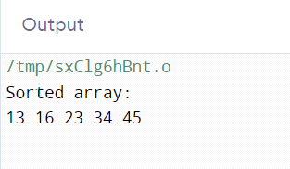

Exp4: Binary Search in C

#include <stdio.h>

int binarySearch(int array[], int x, int low, int high) {

// Repeat until the pointers low and high meet each other

while (low <= high) {

int mid = low + (high - low) / 2;

if (array[mid] == x)

return mid;

if (array[mid] < x)

low = mid + 1;

else

high = mid - 1;

}

return -1;

}

int main(void) {

int array[] = {3, 4, 5, 6, 7, 8, 9};

int n = sizeof(array) / sizeof(array[0]);

int x = 4;

int result = binarySearch(array, x, 0, n - 1);

if (result == -1)

printf("Not found");

else

printf("Element is found at index %d", result);

return 0;

}

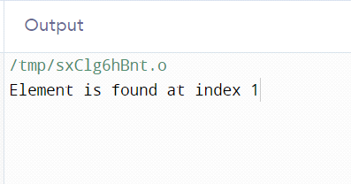

Exp 3:quick sort

#include <stdio.h>

#include<conio.h>

// Function to swap two elements

void swap(int* a, int* b) {

int temp = *a;

*a = *b;

*b = temp;

}

// Function to partition the array and return the pivot index

int partition(int arr[], int low, int high) {

int pivot = arr[high]; // Choose the last element as the pivot

int i = (low - 1); // Index of smaller element

int j;

for (j = low; j <= high - 1; j++) {

// If current element is smaller than or equal to pivot

if (arr[j] <= pivot) {

i++; // Increment index of smaller element

swap(&arr[i], &arr[j]);

}

}

swap(&arr[i + 1], &arr[high]);

return (i + 1); // Return the partition index

}

// Function to perform Quick Sort

void quickSort(int arr[], int low, int high) {

if (low < high) {

// Get the partition index

int partitionIndex = partition(arr, low, high);

// Recursively sort the left and right subarrays

quickSort(arr, low, partitionIndex - 1);

quickSort(arr, partitionIndex + 1, high);

}

}

// Driver code

int main() {

int i;

int arr[] = {12, 11, 13, 5, 6, 7};

int n = sizeof(arr) / sizeof(arr[0]);

printf("Original array: ");

for (i = 0; i < n; i++)

printf("%d ", arr[i]);

printf("\n");

quickSort(arr, 0, n - 1);

printf("Sorted array: ");

for (i = 0; i < n; i++)

printf("%d ", arr[i]);

printf("\n");

return 0;

}

Output:

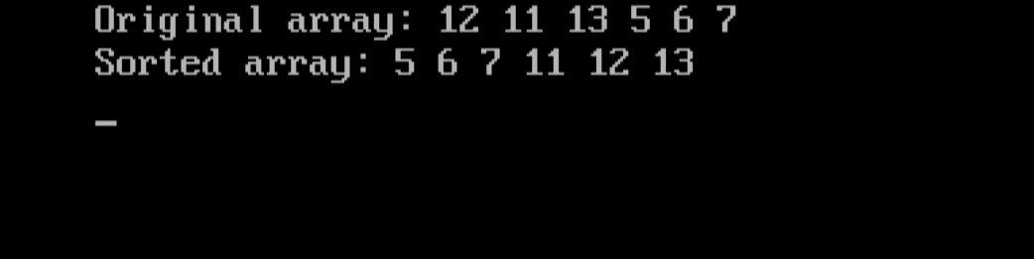

Experiment 5: knapsack problems

code:

#include <stdio.h>

void main()

{

int capacity, no_items, cur_weight, item;

int used[10];

float total_profit;

int i;

int weight[10];

int value[10];

printf("Enter the capacity of knapsack:\n");

scanf("%d", &capacity);

printf("Enter the number of items:\n");

scanf("%d", &no_items);

printf("Enter the weight and value of %d item:\n", no_items);

for (i = 0; i < no_items; i++)

{

printf("Weight[%d]:\t", i);

scanf("%d", &weight[i]);

printf("Value[%d]:\t", i);

scanf("%d", &value[i]);

}

for (i = 0; i < no_items; ++i)

used[i] = 0;

cur_weight = capacity;

while (cur_weight > 0)

{

item = -1;

for (i = 0; i < no_items; ++i)

if ((used[i] == 0) &&

((item == -1) || ((float) value[i] / weight[i] > (float) value[item] / weight[item])))

item = i;

used[item] = 1;

cur_weight -= weight[item];

total_profit += value[item];

if (cur_weight >= 0)

printf("Added object %d (%d Rs., %dKg) completely in the bag. Space left: %d.\n", item + 1, value[item], weight[item], cur_weight);

else

{

int item_percent = (int) ((1 + (float) cur_weight / weight[item]) * 100);

printf("Added %d%% (%d Rs., %dKg) of object %d in the bag.\n", item_percent, value[item], weight[item], item + 1);

total_profit -= value[item];

total_profit += (1 + (float)cur_weight / weight[item]) * value[item];

}

}

printf("Filled the bag with objects worth %.2f Rs.\n", total_profit);

}

output:

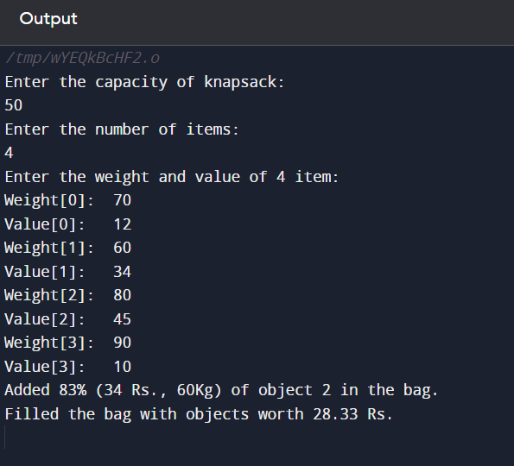

Experiment 6: To implement Prim’s MST Algorithm using Greedy Method.

Code:

// A C program for Prim's Minimum

// Spanning Tree (MST) algorithm. The program is

// for adjacency matrix representation of the graph

#include <limits.h>

#include <stdbool.h>

#include <stdio.h>

// Number of vertices in the graph

#define V 5

// A utility function to find the vertex with

// minimum key value, from the set of vertices

// not yet included in MST

int minKey(int key[], bool mstSet[])

{

// Initialize min value

int min = INT_MAX, min_index;

for (int v = 0; v < V; v++)

if (mstSet[v] == false && key[v] < min)

min = key[v], min_index = v;

return min_index;

}

// A utility function to print the

// constructed MST stored in parent[]

int printMST(int parent[], int graph[V][V])

{

printf("Edge \tWeight\n");

for (int i = 1; i < V; i++)

printf("%d - %d \t%d \n", parent[i], i,

graph[i][parent[i]]);

}

// Function to construct and print MST for

// a graph represented using adjacency

// matrix representation

void primMST(int graph[V][V])

{

// Array to store constructed MST

int parent[V];

// Key values used to pick minimum weight edge in cut

int key[V];

// To represent set of vertices included in MST

bool mstSet[V];

// Initialize all keys as INFINITE

for (int i = 0; i < V; i++)

key[i] = INT_MAX, mstSet[i] = false;

// Always include first 1st vertex in MST.

// Make key 0 so that this vertex is picked as first

// vertex.

key[0] = 0;

// First node is always root of MST

parent[0] = -1;

// The MST will have V vertices

for (int count = 0; count < V - 1; count++) {

// Pick the minimum key vertex from the

// set of vertices not yet included in MST

int u = minKey(key, mstSet);

// Add the picked vertex to the MST Set

mstSet[u] = true;

// Update key value and parent index of

// the adjacent vertices of the picked vertex.

// Consider only those vertices which are not

// yet included in MST

for (int v = 0; v < V; v++)

// graph[u][v] is non zero only for adjacent

// vertices of m mstSet[v] is false for vertices

// not yet included in MST Update the key only

// if graph[u][v] is smaller than key[v]

if (graph[u][v] && mstSet[v] == false

&& graph[u][v] < key[v])

parent[v] = u, key[v] = graph[u][v];

}

// print the constructed MST

printMST(parent, graph);

}

// Driver's code

int main()

{

int graph[V][V] = { { 0, 2, 0, 6, 0 },

{ 2, 0, 3, 8, 5 },

{ 0, 3, 0, 0, 7 },

{ 6, 8, 0, 0, 9 },

{ 0, 5, 7, 9, 0 } };

// Print the solution

primMST(graph);

return 0;

}

Output:

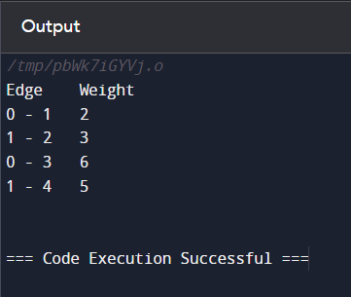`

Experiment 7: To implement Kruskal’s MST Algorithm using Greedy Method.

Code:

// C code to implement Kruskal's algorithm

#include <stdio.h>

#include <stdlib.h>

// Comparator function to use in sorting

int comparator(const void* p1, const void* p2)

{

const int(*x)[3] = p1;

const int(*y)[3] = p2;

return (*x)[2] - (*y)[2];

}

// Initialization of parent[] and rank[] arrays

void makeSet(int parent[], int rank[], int n)

{

for (int i = 0; i < n; i++) {

parent[i] = i;

rank[i] = 0;

}

}

// Function to find the parent of a node

int findParent(int parent[], int component)

{

if (parent[component] == component)

return component;

return parent[component]

= findParent(parent, parent[component]);

}

// Function to unite two sets

void unionSet(int u, int v, int parent[], int rank[], int n)

{

// Finding the parents

u = findParent(parent, u);

v = findParent(parent, v);

if (rank[u] < rank[v]) {

parent[u] = v;

}

else if (rank[u] > rank[v]) {

parent[v] = u;

}

else {

parent[v] = u;

// Since the rank increases if

// the ranks of two sets are same

rank[u]++;

}

}

// Function to find the MST

void kruskalAlgo(int n, int edge[n][3])

{

// First we sort the edge array in ascending order

// so that we can access minimum distances/cost

qsort(edge, n, sizeof(edge[0]), comparator);

int parent[n];

int rank[n];

// Function to initialize parent[] and rank[]

makeSet(parent, rank, n);

// To store the minimun cost

int minCost = 0;

printf(

"Following are the edges in the constructed MST\n");

for (int i = 0; i < n; i++) {

int v1 = findParent(parent, edge[i][0]);

int v2 = findParent(parent, edge[i][1]);

int wt = edge[i][2];

// If the parents are different that

// means they are in different sets so

// union them

if (v1 != v2) {

unionSet(v1, v2, parent, rank, n);

minCost += wt;

printf("%d -- %d == %d\n", edge[i][0],

edge[i][1], wt);

}

}

printf("Minimum Cost Spanning Tree: %d\n", minCost);

}

// Driver code

int main()

{

int edge[5][3] = { { 0, 1, 10 },

{ 0, 2, 6 },

{ 0, 3, 5 },

{ 1, 3, 15 },

{ 2, 3, 4 } };

kruskalAlgo(5, edge);

return 0;

}

Output:

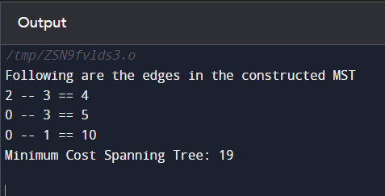

Experiment 8: To implement Single Source Shortest Path Algorithm using Dynamic (Bellman Ford) Method

Code: // Bellman Ford Algorithm in C

#include <stdio.h>

#include <stdlib.h>

#define INFINITY 99999

//struct for the edges of the graph

struct Edge {

int u; //start vertex of the edge

int v; //end vertex of the edge

int w; //weight of the edge (u,v)

};

//Graph - it consists of edges

struct Graph {

int V; //total number of vertices in the graph

int E; //total number of edges in the graph

struct Edge *edge; //array of edges

};

void bellmanford(struct Graph *g, int source);

void display(int arr[], int size);

int main(void) {

//create graph

struct Graph *g = (struct Graph *)malloc(sizeof(struct Graph));

g->V = 4; //total vertices

g->E = 5; //total edges

//array of edges for graph

g->edge = (struct Edge *)malloc(g->E * sizeof(struct Edge));

//------- adding the edges of the graph

/*

edge(u, v)

where u = start vertex of the edge (u,v)

v = end vertex of the edge (u,v)

w is the weight of the edge (u,v)

*/

//edge 0 --> 1

g->edge[0].u = 0;

g->edge[0].v = 1;

g->edge[0].w = 5;

//edge 0 --> 2

g->edge[1].u = 0;

g->edge[1].v = 2;

g->edge[1].w = 4;

//edge 1 --> 3

g->edge[2].u = 1;

g->edge[2].v = 3;

g->edge[2].w = 3;

//edge 2 --> 1

g->edge[3].u = 2;

g->edge[3].v = 1;

g->edge[3].w = 6;

//edge 3 --> 2

g->edge[4].u = 3;

g->edge[4].v = 2;

g->edge[4].w = 2;

bellmanford(g, 0); //0 is the source vertex

return 0;

}

void bellmanford(struct Graph *g, int source) {

//variables

int i, j, u, v, w;

//total vertex in the graph g

int tV = g->V;

//total edge in the graph g

int tE = g->E;

//distance array

//size equal to the number of vertices of the graph g

int d[tV];

//predecessor array

//size equal to the number of vertices of the graph g

int p[tV];

//step 1: fill the distance array and predecessor array

for (i = 0; i < tV; i++) {

d[i] = INFINITY;

p[i] = 0;

}

//mark the source vertex

d[source] = 0;

//step 2: relax edges |V| - 1 times

for (i = 1; i <= tV - 1; i++) {

for (j = 0; j < tE; j++) {

//get the edge data

u = g->edge[j].u;

v = g->edge[j].v;

w = g->edge[j].w;

if (d[u] != INFINITY && d[v] > d[u] + w) {

d[v] = d[u] + w;

p[v] = u;

}

}

}

//step 3: detect negative cycle

//if value changes then we have a negative cycle in the graph

//and we cannot find the shortest distances

for (i = 0; i < tE; i++) {

u = g->edge[i].u;

v = g->edge[i].v;

w = g->edge[i].w;

if (d[u] != INFINITY && d[v] > d[u] + w) {

printf("Negative weight cycle detected!\n");

return;

}

}

//No negative weight cycle found!

//print the distance and predecessor array

printf("Distance array: ");

display(d, tV);

printf("Predecessor array: ");

display(p, tV);

}

void display(int arr[], int size) {

int i;

for (i = 0; i < size; i++) {

printf("%d ", arr[i]);

}

printf("\n");

}

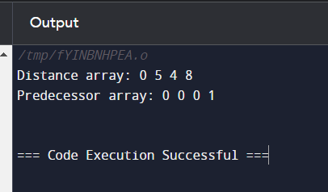

Experiment 9: To implement Travelling Salesperson Problem using Dynamic Approach.

Code:

#include <stdio.h>

#include <limits.h>

#define MAX 9999

int n = 4;

int distan[20][20] = {

{0, 22, 26, 30},

{30, 0, 45, 35},

{25, 45, 0, 60},

{30, 35, 40, 0}};

int DP[32][8];

int TSP(int mark, int position) {

int completed_visit = (1 << n) - 1;

if (mark == completed_visit) {

return distan[position][0];

}

if (DP[mark][position] != -1) {

return DP[mark][position];

}

int answer = MAX;

for (int city = 0; city < n; city++) {

if ((mark & (1 << city)) == 0) {

int newAnswer = distan[position][city] + TSP(mark | (1 << city), city);

answer = (answer < newAnswer) ? answer : newAnswer;

}

}

return DP[mark][position] = answer;

}

int main() {

for (int i = 0; i < (1 << n); i++) {

for (int j = 0; j < n; j++) {

DP[i][j] = -1;

}

}

printf("Minimum Distance Travelled -> %d\n", TSP(1, 0));

return 0;

}

Output:

Experiment 10: To implement Sub of Subset problem using Backtracking method.

Code:

#include <stdio.h>

#define SIZE 7

void displaySubset(int subSet[], int size) {

for(int i = 0; i < size; i++) {

printf("%d ", subSet[i]);

}

printf("\n");

}

void subsetSum(int set[], int subSet[], int n, int subSize, int total, int nodeCount ,int sum) {

if( total == sum) {

displaySubset(subSet, subSize);

if (subSize != 0)

subsetSum(set,subSet,n,subSize-2,total-set[nodeCount],nodeCount+1,sum);

return;

}else {

for( int i = nodeCount; i < n; i++ ) {

subSet[subSize] = set[i];

subsetSum(set,subSet,n,subSize+1,total+set[i],i+1,sum);

}

}

}

void findSubset(int set[], int size, int sum) {

int subSet[size];

subsetSum(set, subSet, size, 0, 0, 0, sum);

}

int main() {

int weights[] = {1, 9, 7, 5, 18, 12, 20, 15};

int size = SIZE;

findSubset(weights, size, 35);

return 0;

}

Output:

Experiment 11: To implement N queen problem using Branch and Bound Method.

Code:

#include<bits/stdc++.h>

using namespace std;

int N;

// function for printing the solution

void printSol(vector<vector<int>>board)

{

for(int i = 0;i<N;i++){

for(int j = 0;j<N;j++){

cout<<board[i][j]<<" ";

}

cout<<"\n";

}

}

/* Optimized isSafe function

isSafe function to check if current row contains or current left diagonal or current right diagonal contains any queen or not if

yes return false

else return true

*/

bool isSafe(int row ,int col ,vector<bool>rows , vector<bool>left_digonals ,vector<bool>Right_digonals)

{

if(rows[row] == true || left_digonals[row+col] == true || Right_digonals[col-row+N-1] == true){

return false;

}

return true;

}

// Recursive function to solve N-queen Problem

bool solve(vector<vector<int>>& board ,int col ,vector<bool>rows , vector<bool>left_digonals ,vector<bool>Right_digonals)

{

// base Case : If all Queens are placed

if(col>=N){

return true;

}

/* Consider this Column and move in all rows one by one */

for(int i = 0;i<N;i++)

{

if(isSafe(i,col,rows,left_digonals,Right_digonals) == true)

{

rows[i] = true;

left_digonals[i+col] = true;

Right_digonals[col-i+N-1] = true;

board[i][col] = 1; // placing the Queen in board[i][col]

/* recur to place rest of the queens */

if(solve(board,col+1,rows,left_digonals,Right_digonals) == true){

return true;

}

// Backtracking

rows[i] = false;

left_digonals[i+col] = false;

Right_digonals[col-i+N-1] = false;

board[i][col] = 0; // removing the Queen from board[i][col]

}

}

return false;

}

int main()

{

// Taking input from the user

cout<<"Enter the no of rows for the square Board : ";

cin>>N;

// board of size N*N

vector<vector<int>>board(N,vector<int>(N,0));

// array to tell which rows are occupied

vector<bool>rows(N,false);

// arrays to tell which diagonals are occupied

vector<bool>left_digonals(2*N-1,false);

vector<bool>Right_digonals(2*N-1,false);

bool ans = solve(board , 0, rows,left_digonals,Right_digonals);

if(ans == true){

// printing the solution Board

printSol(board);

}

else{

cout<<"Solution Does not Exist\n";

}

}

Output:

Experiment 12: Implement the Naïve string-matching algorithm and analyze its complexity.

Code:

// C program for Naive Pattern Searching algorithm

#include <stdio.h>

#include <string.h>

void search(char* pat, char* txt)

{

int M = strlen(pat);

int N = strlen(txt);

/* A loop to slide pat[] one by one */

for (int i = 0; i <= N - M; i++) {

int j;

/* For current index i, check for pattern match */

for (j = 0; j < M; j++)

if (txt[i + j] != pat[j])

break;

if (j

== M) // if pat[0...M-1] = txt[i, i+1, ...i+M-1]

printf("Pattern found at index %d \n", i);

}

}

// Driver's code

int main()

{

char txt[] = "AABAACAADAABAAABAA";

char pat[] = "AABA";

// Function call

search(pat, txt);

return 0;

}

Output:

